DATA VISUALIZATION AND INSIGHT COMMUNICATION USING R
Project Title: Airline Passenger Satisfaction – Data Visualization and Analysis
Dataset: Airline Passenger Satisfaction Dataset
Programming Language: R
Visualization Tool: RStudio and ggplot2
Assignment: Week 2 Task

1. Introduction
Data visualization is an important part of data analysis because it helps transform raw data into meaningful graphical information. Visual representations make it easier to identify patterns, relationships, distributions and trends within a dataset.
This project focuses on analysing an Airline Passenger Satisfaction dataset using the R programming language. The dataset contains passenger information, travel details, airline service ratings, flight distances, delays and satisfaction levels.
The project uses the ggplot2 package in R to create different types of visualizations, including bar charts, histograms, scatter plots, line charts and a correlation heatmap.
The main purpose is to identify useful insights from airline passenger data and communicate the findings in a clear and understandable way.
2. Project Objectives
The main objectives of this project are:
- To explore and understand the Airline Passenger Satisfaction dataset.
- To create different visualizations using R and ggplot2.
- To analyse passenger satisfaction across different categories.
- To understand passenger age and flight-distance distributions.
- To examine relationships between flight delays and passenger-related variables.
- To identify correlations between numerical variables.
- To communicate analytical findings through graphs and interpretations.

3.Dataset Overview
The Airline Passenger Satisfaction dataset was selected for this project. It contains information about airline passengers, their travel characteristics, service ratings and satisfaction levels.
Dataset details:
Description | Details
Dataset name | Airline Passenger Satisfaction
Total records | 103,904
Original variables | 25
Cleaned variables | 33
Missing values after cleaning | 0
Duplicate records | 0
Data analysis tool | RStudio
Visualization package | ggplot2
The cleaned dataset prepared during Week 1 was used for the visualization process in Week 2.
4. Data Visualization and Analysis
4.1 Passenger Satisfaction Distribution
Visualization Type: Bar Chart
Objective:
The purpose of this visualization is to understand the overall distribution of passenger satisfaction levels in the airline dataset.
R Code:
ggplot(raw_data, aes(x = satisfaction)) +
geom_bar(fill = "steelblue") +
labs(
title = "Passenger Satisfaction Distribution",
x = "Satisfaction Level",
y = "Number of Passengers"
) +
theme_minimal()
Interpretation:
The bar chart compares the number of passengers who are satisfied with those who are neutral or dissatisfied. It provides a clear overview of the overall satisfaction distribution in the airline dataset.
Significance:
Airline management can use this visualization to understand general passenger satisfaction and identify the importance of improving customer experience.
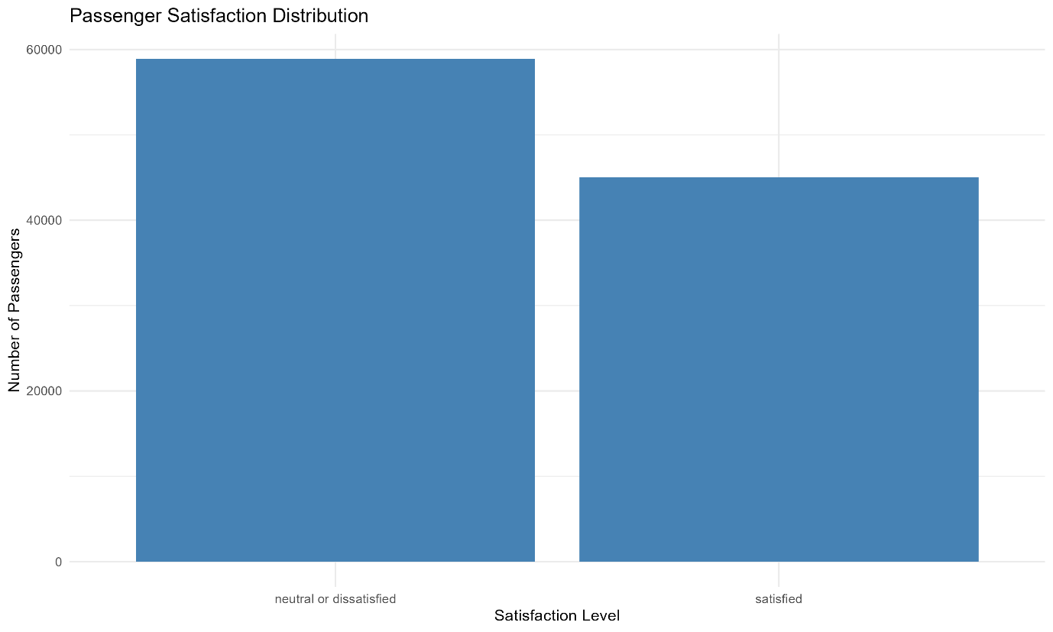
4.2 Age Distribution of Airline Passengers
Visualization Type: Histogram
Objective:
This histogram analyses the age distribution of passengers and identifies how passenger records are spread across different age groups.
R Code:
ggplot(raw_data, aes(x = age)) +
geom_histogram(
binwidth = 5,
fill = "steelblue",
color = "black"
) +
labs(
title = "Age Distribution of Airline Passengers",
x = "Passenger Age",
y = "Number of Passengers"
) +
theme_minimal()
Interpretation:
The histogram groups passenger ages into intervals of five years. It helps identify the distribution of passenger ages and compare the number of records across different age ranges.
Significance:
This information can help airlines understand the age composition of their passengers and plan suitable services for different customer groups.

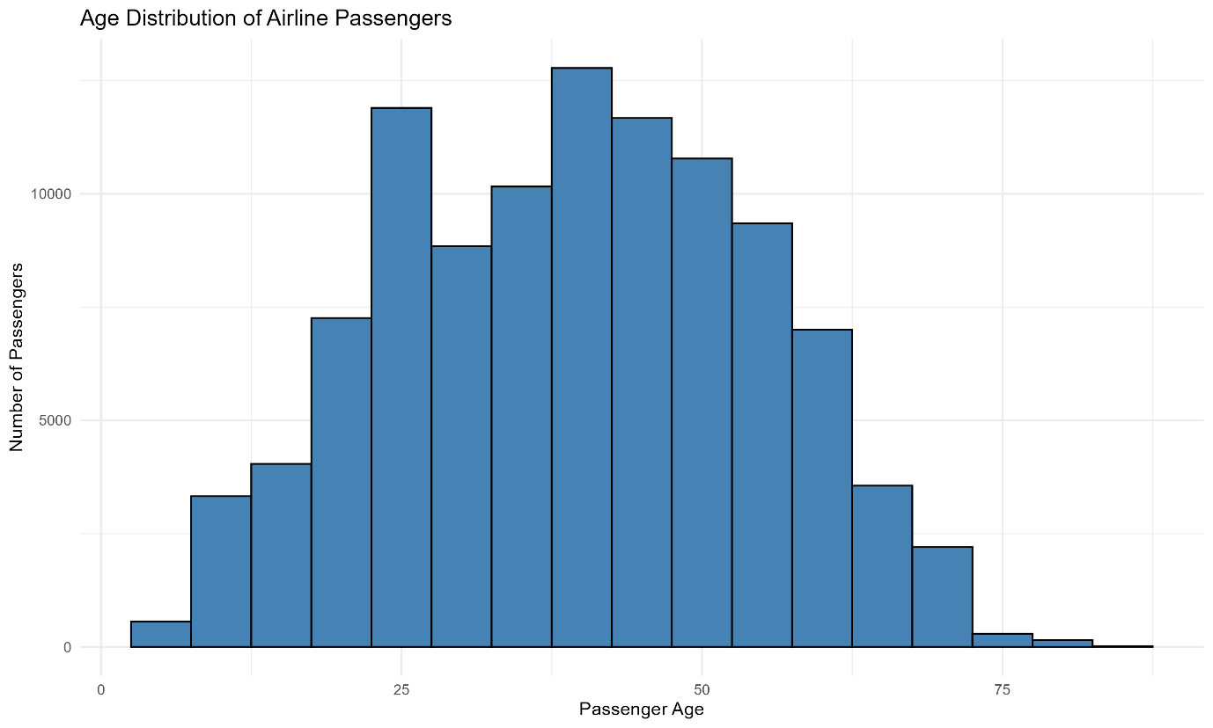

4.3 Distribution of Flight Distance
Visualization Type: Histogram
Objective:
The objective of this visualization is to understand the distribution of flight distances recorded in the airline passenger dataset.
R Code:
ggplot(raw_data, aes(x = flight_distance)) +
geom_histogram(
binwidth = 200,
fill = "orange",
color = "black"
) +
labs(
title = "Distribution of Flight Distance",
x = "Flight Distance",
y = "Number of Passengers"
) +
theme_minimal()
Interpretation:
The histogram represents the distribution of flight distances using intervals of 200 distance units. It helps identify how passenger records are distributed across shorter and longer flights.
Significance:
This visualization can help airline management understand the range of travel distances and support decisions related to route planning and service allocation.

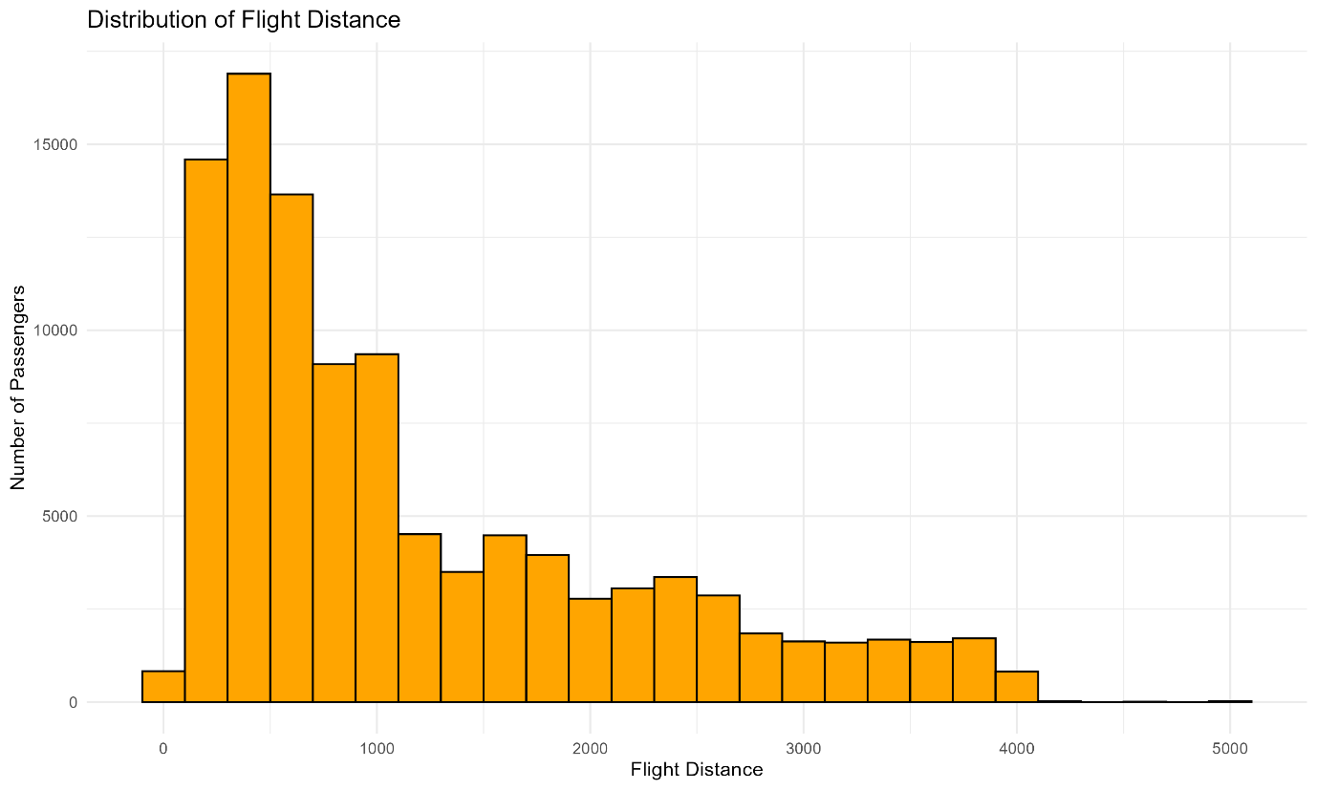
4.4 Customer Type vs Passenger Satisfaction
Visualization Type: Grouped Bar Chart
Objective:
The objective is to compare passenger satisfaction levels between loyal and disloyal customers.
R Code:
ggplot(raw_data,
aes(x = customer_type, fill = satisfaction)) +
geom_bar(position = "dodge") +
labs(
title = "Customer Type vs Passenger Satisfaction",
x = "Customer Type",
y = "Number of Passengers",
fill = "Satisfaction Level"
) +
theme_minimal()
Interpretation:
The grouped bar chart compares the number of satisfied and neutral or dissatisfied passengers across different customer types. The separate bars make it easier to compare the satisfaction counts.
Significance:
This visualization helps airlines understand customer satisfaction patterns among loyal and disloyal passengers. It can support customer retention strategies and service improvement decisions.
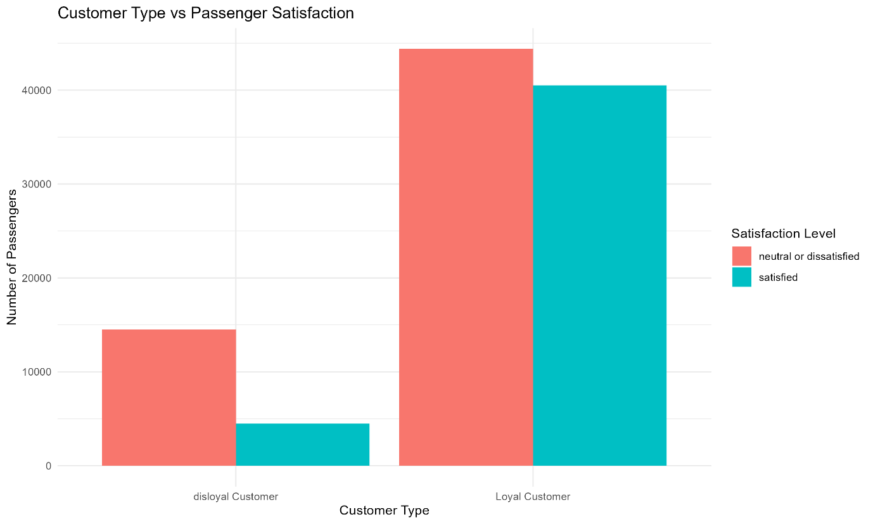
4.5 Flight Distance vs Arrival Delay
Visualization Type: Scatter Plot
Objective:
The objective of this visualization is to examine the relationship between flight distance and arrival delay.
R Code:
ggplot(raw_data,
aes(x = flight_distance,
y = arrival_delay_in_minutes)) +
geom_point(
color = "steelblue",
alpha = 0.3
) +
labs(
title = "Flight Distance vs Arrival Delay",
x = "Flight Distance",
y = "Arrival Delay (Minutes)"
) +
theme_minimal()
Interpretation:
The scatter plot represents the relationship between flight distance and arrival delay. Each point represents a passenger record. The visualization helps identify patterns, variations and unusual observations in the data.
Significance:
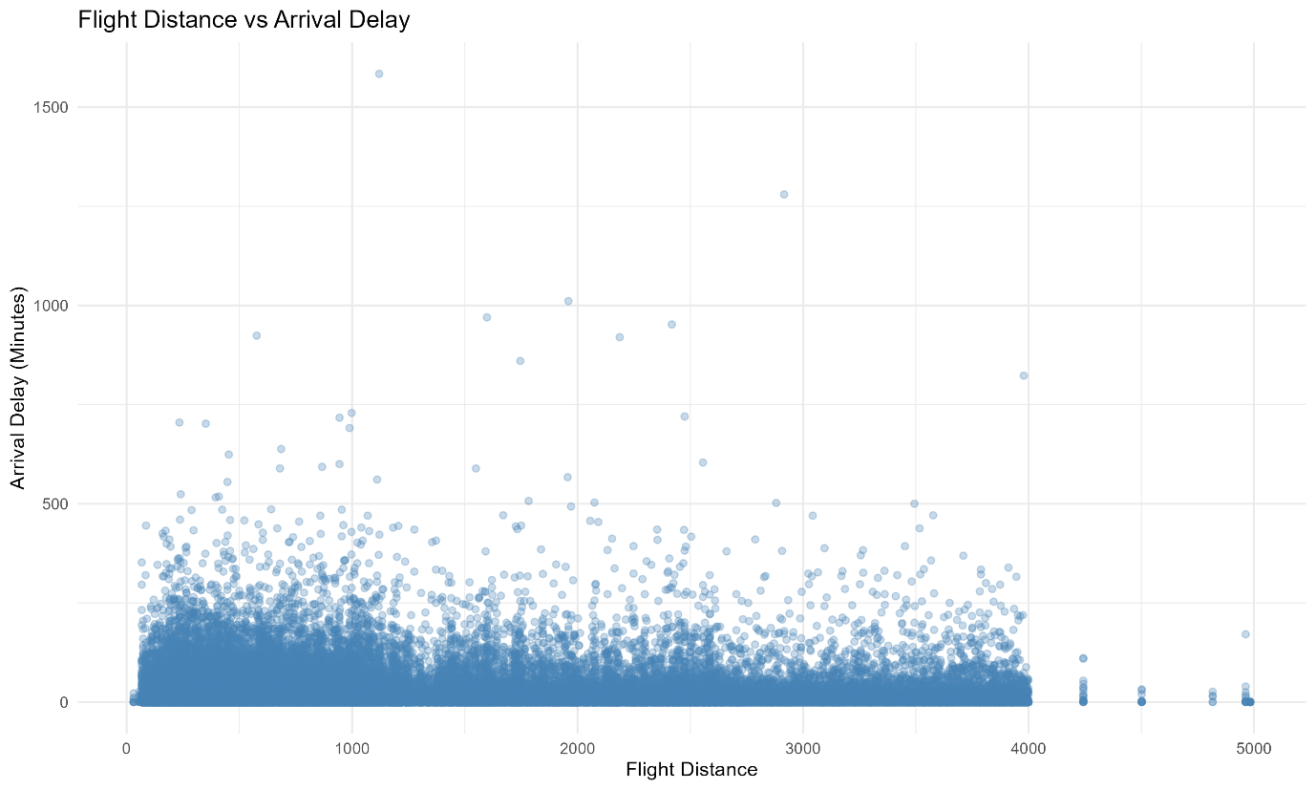
This analysis can help airline management explore whether flight distance is associated with arrival delays. It can also support further investigation into operational performance.

4.6 Average Arrival Delay by Age Group and Travel Type
Visualization Type: Line Chart
Objective:
The objective of this visualization is to compare average arrival delays across different passenger age groups and travel types.
R Code:
delay_data <- raw_data %>%
mutate(
age_group = cut(
age,
breaks = c(0, 20, 30, 40, 50, 60, 100),
labels = c(
"0-20", "21-30", "31-40",
"41-50", "51-60", "61+"
),
include.lowest = TRUE
)
) %>%
group_by(age_group, type_of_travel) %>%
summarise(
avg_delay = mean(arrival_delay_in_minutes),
.groups = "drop"
)

ggplot(
delay_data,
aes(
x = age_group,
y = avg_delay,
group = type_of_travel,
color = type_of_travel
)
) +
geom_line(linewidth = 1) +
geom_point(size = 3) +
labs(
title = "Average Arrival Delay by Age Group and Travel Type",
x = "Passenger Age Group",
y = "Average Arrival Delay (Minutes)",
color = "Travel Type"
) +
theme_minimal()
Interpretation:
The line chart compares average arrival delays across different age groups for personal and business travel. It helps identify differences in average delays between the two travel categories.
Significance:
This visualization helps communicate differences in average arrival delays across passenger groups and provides an opportunity for further operational analysis.
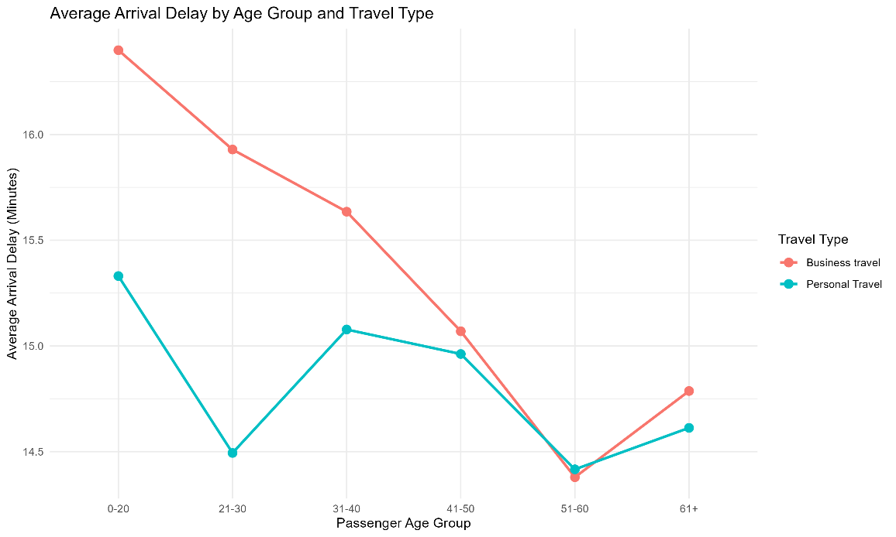
4.7 Passenger Satisfaction by Travel Class
Visualization Type: Proportional Bar Chart (100% Stacked Bar Chart)
Objective:
The objective of this visualization is to compare passenger satisfaction proportions across Business, Eco and Eco Plus travel classes.
R Code:
ggplot(raw_data,
aes(x = class, fill = satisfaction)) +
geom_bar(position = "fill") +
labs(
title = "Passenger Satisfaction by Travel Class",
x = "Travel Class",
y = "Proportion of Passengers",
fill = "Satisfaction Level"
) +
scale_y_continuous(
labels = scales::percent
) +
theme_minimal()
Interpretation:
The proportional bar chart compares the percentage distribution of satisfied and neutral or dissatisfied passengers across different travel classes. Each bar represents 100% of the passenger records within that class.
Significance:
This visualization helps airline management compare satisfaction patterns across different travel classes and identify areas where service improvements may be useful.
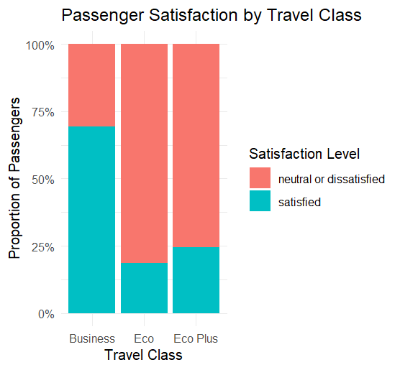
4.8 Correlation Heatmap of Airline Variables
Visualization Type: Correlation Heatmap
Objective:
The objective of this visualization is to identify relationships between selected numerical variables in the airline passenger dataset.
R Code:
numeric_data <- raw_data[, c(
"age",
"flight_distance",
"departure_delay_in_minutes",
"arrival_delay_in_minutes",
"inflight_wifi_service",
"food_and_drink",
"seat_comfort",
"cleanliness"
)]

correlation_matrix <- cor(numeric_data)

correlation_df <- as.data.frame(
as.table(correlation_matrix)
)

ggplot(correlation_df,
aes(x = Var1, y = Var2, fill = Freq)) +
geom_tile(color = "white") +
geom_text(
aes(label = round(Freq, 2)),
size = 3
) +
scale_fill_gradient2(
low = "blue",
mid = "white",
high = "red",
midpoint = 0,
limits = c(-1, 1)
) +
labs(
title = "Correlation Heatmap of Airline Variables",
x = "Variables",
y = "Variables",
fill = "Correlation"
) +
theme_minimal() +
theme(
axis.text.x = element_text(
angle = 45,
hjust = 1
)
)
Interpretation:
The correlation heatmap represents the relationships between selected numerical variables. The correlation values range from -1 to +1, indicating negative, positive or weak linear relationships.
The analysis identified a strong positive correlation of 0.96 between departure delay and arrival delay. Seat comfort and cleanliness also showed a positive correlation of 0.68.
Significance:
The heatmap helps identify relationships between airline operational variables and passenger service ratings. These findings can support further investigation into operational performance and passenger experience.
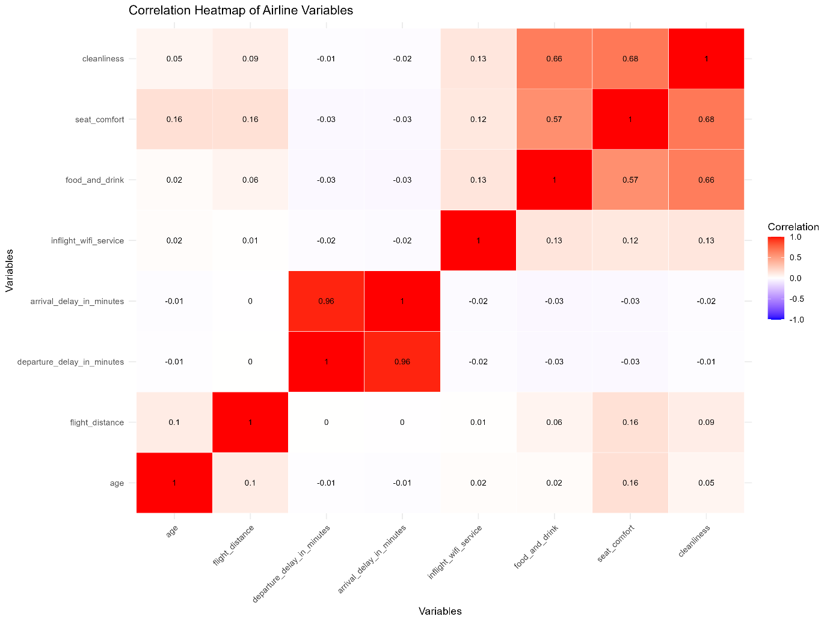
5. Conclusion
This project demonstrated the use of R programming for data visualization and insight communication using the Airline Passenger Satisfaction dataset.
Eight visualizations were created using the ggplot2 package, including bar charts, histograms, a scatter plot, a line chart, a proportional bar chart and a correlation heatmap.
The analysis identified a strong positive correlation of 0.96 between departure delay and arrival delay. A positive correlation of 0.68 was also observed between seat comfort and cleanliness.
The visualizations helped transform numerical and categorical information into understandable graphical representations. They also demonstrated how data visualization can support the identification of patterns and relationships within airline passenger data.
Overall, this project improved practical knowledge of R programming, graphical representation, exploratory data analysis and communicating analytical findings to a non-technical audience.

